How Focused Should the Newco Board Be on Valuation?

In Compensating the CEO, What Measures Should Be Used to Reward “Innovation?”

Setting and Introduction:

This discussion begins with a focus on Newco, an emerging, venture backed, technology company. It operates in a high growth area of pharmaceutical research related to heart disease. Being on the cutting edge of technology is critical. Current sales are about $1m and Net Income is 5%.
It is early in the life cycle.
At this point, the company seeks to grow. Perhaps in 5-7 years it will be time to get acquired. Since there will be an exit, the Board wants to keep the CEO’s focus on that goal.
Some possible operating numbers include:

Revenue | 100%
CoG | 45%
Gross Margin | 55%
SGA
R and D | 15%
Mkt | 15%
Admin | 10%
EBITA | 15%
Net Income | 05%
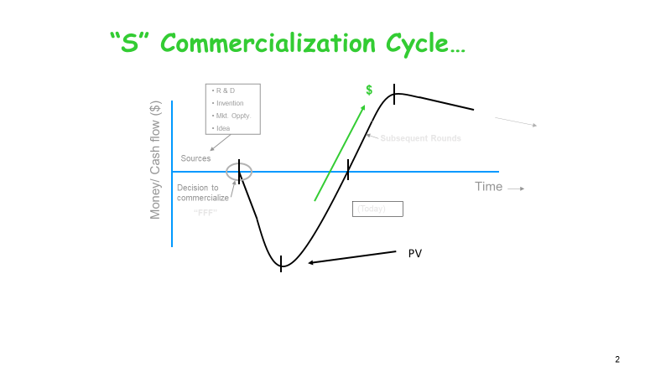
When the original investment tranche was negotiated, the project was valued at $2m. There was a discussion about Sustainable Value Proposition (SVP) as the investors were interested in a 7 - 10 year, 10x future cash flow payout.
Valuation:
The venture capital firm that invested in Newco looks forward to future payouts. As such, they are guided by certain principles. They include:
- Riskier investments require higher payoffs
- Reliance on historical data
- Use of multiples (and industry “comparable data”)
- Price to Earnings is a key indicator
- Leverage potential of Balance Sheet cash
- Price to book ratio (measure of future potential of how much has been invested)
- Equity to book value
- Discounted Future Earnings

The Chair of the Board is venture capital partner Karen McDermott. Her mantra is “valuation.” She wants the Board and the CEO to be on the “Valuation Bandwagon” and not simply focus on EBITDA.

THE LANDSCAPE OF VALUATION:
The landscape of future Valuation is broad and is characterized by professionals who are certified by the National Association of Certified Valuators and Analysts (NACVA). The organization not only sets standards for formal certifications, but also provides seminars and workshops to helps keep members current.
There is no single domain of valuations. It takes on different dimensions of formality and detail as situations demand. The transaction of selling a private business might be a ten-page document where the viability of assets and expenditures are reviewed. They are also couched in either comparative or analytical terms (or both). They are not unlike formal accounting audits processes but seem to be focused on the future value of the entity. They serve as a framework for supporting the transactions or at least proving the validity of the transaction proposals.

DISCOUNTED CASH FLOW:
One of the primary valuation tools was developed in the 1970s. It was coined Discounted Cash Flow (DCF). It rationalized the future corporate cashflows and then discounted them to a Present Value (PV). It allowed for a convenient method of comparing multiple projects. With time that format was replaced by a weighted average cost of capitals model coined WACC. With the advent of computerized information systems and Analytics, even those tools are somewhat obsolete. Within WACC there is a controversy about how tax calculations occur considering the fixed aspect of its formula. Today it becomes important to evaluate specific functional areas such as operations, opportunities and ownership claims and then synthesize an overall rating.
Certainly, the analytical tools and enabling computational power that are now available make these assessments more readily available.

A Longer View…
Karen likes Valuation because it has longer term dimensions and can be applied o areas such as:
- Options pricing (whether tangible, material items or numerical-i.e. stock)
- Long term capital investment such as plant and equipment
- M & A transactions
- Liquidation scenarios
- Proprietary Ownership scenarios
Innovation…
Karen believes valuation models can contribute to measuring technology innovation.
Specific companies like 3M have appeared on Innovation Indices for almost forty years….yet it is not directly computed into common valuation scenarios.
Karen argues that the tools for organizing these valuation (and other) perspectives have accelerated over the past 25 years. Analytics that would take a room sized computer can be accomplished a desk top device today. The internet provides endless external data that can be utilized. Modeling software has reached almost “shrink wrap” proportions.

Karen: Should Valuation be an agenda topic of Board meetings at Newco?

QUESTIONS FOR DISCUSSION:

If you were on the Board of Directors of Newco, how would you measure innovation for purposes of compensating the CEO? And what time frame would you use?

What is the role of valuation at Boards you have sat on?

Do you agree with Karen that valuation should be an explicit component of the Board agenda every year?

Should valuation at Newco be a full Board issue or an Audit Committee issue.

